Function Demonstration

======================

sensor_measurement(G, uncon_comp_tups, contactor_tups, states)

----------------------

This function returns the measurements of all the sensors using a dictionary data structure, for example, {'S2': 1, 'S1': 0}. “'S1': 0” means sensor 1 displays “unhealthy”. “'S2': 1” means sensor 2 displays “healthy”. The inputs include G, uncontrollable component tuples, contactor tuples, and the given state. G is the given circuit. Uncontrollable component tuples and contactor tuples are given using the function init(G, uncon_comp_tups, contactor_tups). State consists of the performing action (controllable contactors being open or closed) and states of the rest components. The example input states can be states = {'G1': 1, 'G2': 0, 'T1': 0, 'T2': 0, 'C1': 1, 'C2': 1, 'C3': 1, 'C4': 0, 'C5': 0, 'C6': 0}. “'C1': 1” means contactor 1 is closed. “'C4': 0” means contactor 4 is open. “'G1': 1” means generator 1 is healthy. “'G2': 0” means generator 2 is unhealthy.

This function gives the measurements by checking all the paths between each sensor and each generator. Choosing one path, if any contactor along the path is open, then this is not a live path, so there is no need to check the states of the rest components. If all the contactors are closed, then the states of the rest components will be checked. If any component is unhealthy then the sensor will display “unhealthy”. Otherwise, it is healthy.

Examples:

**example_sensor_1.py**

states = {'G1': 1, 'G2': 1, 'T1': 1, 'T2': 1, 'C1': 1, 'C2': 1, 'C3': 1, 'C4': 1, 'C5': 1, 'C6': 1}

{'S2': 1, 'S1': 1}

states = {'G1': 0, 'G2': 1, 'T1': 1, 'T2': 1, 'C1': 1, 'C2': 1, 'C3': 1, 'C4': 0, 'C5': 1, 'C6': 0}

{'S2': 1, 'S1': 0}

states = {'G1': 1, 'G2': 0, 'T1': 0, 'T2': 0, 'C1': 0, 'C2': 1, 'C3': 1, 'C4': 1, 'C5': 1, 'C6': 1}

{'S2': 0, 'S1': 1}

states = {'G1': 0, 'G2': 0, 'T1': 1, 'T2': 1, 'C1': 0, 'C2': 1, 'C3': 1, 'C4': 1, 'C5': 1, 'C6': 1}

{'S2': 0, 'S1': 0}

**example_sensor_2.py**

states = {'G1': 1, 'G2': 1, 'G3': 1, 'T1': 1, 'T2': 1, 'C1': 1, 'C2': 1, 'C3': 1, 'C4': 1, 'C5': 1, 'C6': 1, 'C7': 1, 'C8': 1}

{'S3': 1, 'S2': 1, 'S1': 1}

states = {'G1': 0, 'G2': 0, 'G3': 0, 'T1': 1, 'T2': 1, 'C1': 1, 'C2': 1, 'C3': 1, 'C4': 1, 'C5': 1, 'C6': 1, 'C7': 1, 'C8': 1}

{'S3': 0, 'S2': 0, 'S1': 0}

states = {'G1': 0, 'G2': 1, 'G3': 0, 'T1': 1, 'T2': 1, 'C1': 1, 'C2': 0, 'C3': 1, 'C4': 1, 'C5': 0, 'C6': 1, 'C7': 0, 'C8': 1}

{'S3': 1, 'S2': 0, 'S1': 1}

states = {'G1': 0, 'G2': 1, 'G3': 1, 'T1': 1, 'T2': 1, 'C1': 1, 'C2': 1, 'C3': 1, 'C4': 0, 'C5': 1, 'C6': 0, 'C7': 1, 'C8': 1}

{'S3': 0, 'S2': 1, 'S1': 1}

**example_sensor_3.py**

states = {'G1': 0, 'G2': 1, 'G3': 1, 'G4': 1, 'T1': 1, 'T2': 1, 'C1': 1, 'C2': 1, 'C3': 1, 'C4': 0, 'C5': 1, 'C6': 0, 'C7': 1, 'C8': 1, 'C9': 1, 'C10': 1}

{'S3': 0, 'S2': 0, 'S1': 0, 'S4': 0}

states = {'G1': 1, 'G2': 1, 'G3': 1, 'G4': 1, 'T1': 1, 'T2': 1, 'C1': 1, 'C2': 1, 'C3': 1, 'C4': 0, 'C5': 1, 'C6': 0, 'C7': 1, 'C8': 1, 'C9': 1, 'C10': 1}

{'S3': 1, 'S2': 1, 'S1': 1, 'S4': 1}

states = {'G1': 1, 'G2': 1, 'G3': 1, 'G4': 0, 'T1': 1, 'T2': 1, 'C1': 1, 'C2': 1, 'C3': 1, 'C4': 1, 'C5': 1, 'C6': 0, 'C7': 1, 'C8': 1, 'C9': 1, 'C10': 1}

{'S3': 1, 'S2': 1, 'S1': 1, 'S4': 0}

states = {'G1': 0, 'G2': 1, 'G3': 0, 'G4': 0, 'T1': 1, 'T2': 1, 'C1': 1, 'C2': 0, 'C3': 0, 'C4': 1, 'C5': 0, 'C6': 0, 'C7': 1, 'C8': 1, 'C9': 1, 'C10': 1}

{'S3': 1, 'S2': 1, 'S1': 0, 'S4': 0}

compatible_states(G, sensor_readings, con_cont, file_name)

----------------------

This function creates a csv file storing the database of the compatible states given the outcomes of the sensors and the same set of actions. The inputs include the given circuit G, the sensor readings using a dictionary data structure (S_readings = {'S1': 0, 'S2': 0}), the states of the controllable contactors (C_c = {'C1': 1, 'C2': 1, 'C3': 1}), and the output file name.

This function checks all of the states of the controllable components, and by using the function “sensor_measurement”, it gets the sensor readings. Comparing it with the actual sensor readings, if they are the same, the state will be added to the compatible states.

Examples:

**example_sensor_1.py**

C_c = {'C1': 1, 'C2': 1, 'C3': 1, 'C4': 1, 'C5': 1, 'C6': 1}

S_readings = {'S1': 0, 'S2': 1}

|  |  |  |  |  |  |  |  |  |  |
| --- | --- | --- | --- | --- | --- | --- | --- | --- | --- |
| T2 | T1 | G1 | G2 | C3 | C2 | C1 | C6 | C5 | C4 |
| 0 | 0 | 1 | 1 | 1 | 1 | 1 | 1 | 1 | 1 |
| 0 | 1 | 1 | 1 | 1 | 1 | 1 | 1 | 1 | 1 |
| 1 | 0 | 1 | 1 | 1 | 1 | 1 | 1 | 1 | 1 |

C_c = {'C1': 1, 'C2': 1, 'C3': 1, 'C4': 1, 'C5': 1}

S_readings = {'S1': 0, 'S2': 1}

|  |  |  |  |  |  |  |  |  |  |
| --- | --- | --- | --- | --- | --- | --- | --- | --- | --- |
| T2 | T1 | G1 | G2 | C6 | C3 | C2 | C1 | C5 | C4 |
| 0 | 0 | 1 | 1 | 0 | 1 | 1 | 1 | 1 | 1 |
| 0 | 0 | 1 | 1 | 1 | 1 | 1 | 1 | 1 | 1 |
| 0 | 1 | 1 | 1 | 1 | 1 | 1 | 1 | 1 | 1 |
| 1 | 0 | 1 | 1 | 0 | 1 | 1 | 1 | 1 | 1 |
| 1 | 0 | 1 | 1 | 1 | 1 | 1 | 1 | 1 | 1 |

**example_sensor_2.py**

C_c = {'C1': 1, 'C2': 1, 'C3': 1, 'C4': 1, 'C5': 1, 'C6': 1, 'C7': 1}

S_readings = {'S1': 1, 'S2': 1, 'S3': 1}

|  |  |  |  |  |  |  |  |  |  |  |  |  |
| --- | --- | --- | --- | --- | --- | --- | --- | --- | --- | --- | --- | --- |
| T1 | T2 | G1 | G3 | G2 | C8 | C3 | C2 | C1 | C7 | C6 | C5 | C4 |
| 1 | 0 | 1 | 1 | 1 | 0 | 1 | 1 | 1 | 1 | 1 | 1 | 1 |
| 1 | 1 | 1 | 1 | 1 | 0 | 1 | 1 | 1 | 1 | 1 | 1 | 1 |
| 1 | 1 | 1 | 1 | 1 | 1 | 1 | 1 | 1 | 1 | 1 | 1 | 1 |

C_c = {'C1': 1, 'C2': 0, 'C3': 0, 'C4': 1, 'C5': 0, 'C7': 0, 'C8': 1}

S_readings = {'S1': 1, 'S2': 0, 'S3': 1}

|  |  |  |  |  |  |  |  |  |  |  |  |  |
| --- | --- | --- | --- | --- | --- | --- | --- | --- | --- | --- | --- | --- |
| T1 | T2 | G1 | G3 | G2 | C6 | C8 | C3 | C2 | C1 | C7 | C5 | C4 |
| 0 | 0 | 0 | 0 | 1 | 0 | 1 | 0 | 0 | 1 | 0 | 0 | 1 |
| 0 | 0 | 0 | 0 | 1 | 1 | 1 | 0 | 0 | 1 | 0 | 0 | 1 |
| 0 | 0 | 0 | 1 | 1 | 0 | 1 | 0 | 0 | 1 | 0 | 0 | 1 |
| 0 | 0 | 0 | 1 | 1 | 1 | 1 | 0 | 0 | 1 | 0 | 0 | 1 |
| 0 | 1 | 0 | 0 | 1 | 0 | 1 | 0 | 0 | 1 | 0 | 0 | 1 |
| 0 | 1 | 0 | 0 | 1 | 1 | 1 | 0 | 0 | 1 | 0 | 0 | 1 |
| 0 | 1 | 0 | 1 | 1 | 0 | 1 | 0 | 0 | 1 | 0 | 0 | 1 |
| 0 | 1 | 0 | 1 | 1 | 1 | 1 | 0 | 0 | 1 | 0 | 0 | 1 |
| 1 | 0 | 0 | 0 | 1 | 0 | 1 | 0 | 0 | 1 | 0 | 0 | 1 |
| 1 | 0 | 0 | 0 | 1 | 1 | 1 | 0 | 0 | 1 | 0 | 0 | 1 |
| 1 | 0 | 0 | 1 | 1 | 0 | 1 | 0 | 0 | 1 | 0 | 0 | 1 |
| 1 | 0 | 0 | 1 | 1 | 1 | 1 | 0 | 0 | 1 | 0 | 0 | 1 |
| 1 | 1 | 0 | 0 | 1 | 0 | 1 | 0 | 0 | 1 | 0 | 0 | 1 |
| 1 | 1 | 0 | 0 | 1 | 1 | 1 | 0 | 0 | 1 | 0 | 0 | 1 |
| 1 | 1 | 0 | 1 | 1 | 0 | 1 | 0 | 0 | 1 | 0 | 0 | 1 |
| 1 | 1 | 0 | 1 | 1 | 1 | 1 | 0 | 0 | 1 | 0 | 0 | 1 |

**example_sensor_3.py**

C_c = {'C1': 1, 'C3': 1, 'C10': 0, 'C9': 1, 'C4': 0, 'C6': 1, 'C8': 0, 'C5': 1}

S_readings = {'S1': 0, 'S2': 1, 'S3': 0, 'S4': 0}

|  |  |  |  |  |  |  |  |  |  |  |  |  |  |  |  |
| --- | --- | --- | --- | --- | --- | --- | --- | --- | --- | --- | --- | --- | --- | --- | --- |
| T2 | G1 | G3 | G2 | G4 | T1 | C7 | C2 | C9 | C8 | C3 | C1 | C10 | C6 | C5 | C4 |
| 0 | 0 | 0 | 1 | 0 | 0 | 1 | 0 | 1 | 0 | 1 | 1 | 0 | 1 | 1 | 0 |
| 0 | 0 | 0 | 1 | 0 | 1 | 1 | 0 | 1 | 0 | 1 | 1 | 0 | 1 | 1 | 0 |
| 0 | 0 | 0 | 1 | 1 | 0 | 1 | 0 | 1 | 0 | 1 | 1 | 0 | 1 | 1 | 0 |
| 0 | 0 | 0 | 1 | 1 | 1 | 1 | 0 | 1 | 0 | 1 | 1 | 0 | 1 | 1 | 0 |
| 0 | 0 | 1 | 1 | 0 | 0 | 1 | 0 | 1 | 0 | 1 | 1 | 0 | 1 | 1 | 0 |
| 0 | 0 | 1 | 1 | 0 | 1 | 1 | 0 | 1 | 0 | 1 | 1 | 0 | 1 | 1 | 0 |
| 0 | 0 | 1 | 1 | 1 | 0 | 1 | 0 | 1 | 0 | 1 | 1 | 0 | 1 | 1 | 0 |
| 0 | 0 | 1 | 1 | 1 | 1 | 1 | 0 | 1 | 0 | 1 | 1 | 0 | 1 | 1 | 0 |
| 0 | 1 | 0 | 1 | 0 | 0 | 1 | 0 | 1 | 0 | 1 | 1 | 0 | 1 | 1 | 0 |
| 0 | 1 | 0 | 1 | 0 | 1 | 1 | 0 | 1 | 0 | 1 | 1 | 0 | 1 | 1 | 0 |
| 0 | 1 | 0 | 1 | 1 | 0 | 1 | 0 | 1 | 0 | 1 | 1 | 0 | 1 | 1 | 0 |
| 0 | 1 | 0 | 1 | 1 | 1 | 1 | 0 | 1 | 0 | 1 | 1 | 0 | 1 | 1 | 0 |
| 1 | 0 | 0 | 1 | 0 | 0 | 1 | 0 | 1 | 0 | 1 | 1 | 0 | 1 | 1 | 0 |
| 1 | 0 | 0 | 1 | 0 | 1 | 1 | 0 | 1 | 0 | 1 | 1 | 0 | 1 | 1 | 0 |
| 1 | 0 | 0 | 1 | 1 | 0 | 1 | 0 | 1 | 0 | 1 | 1 | 0 | 1 | 1 | 0 |
| 1 | 0 | 0 | 1 | 1 | 1 | 1 | 0 | 1 | 0 | 1 | 1 | 0 | 1 | 1 | 0 |
| 1 | 0 | 1 | 1 | 0 | 0 | 1 | 0 | 1 | 0 | 1 | 1 | 0 | 1 | 1 | 0 |
| 1 | 0 | 1 | 1 | 0 | 1 | 1 | 0 | 1 | 0 | 1 | 1 | 0 | 1 | 1 | 0 |
| 1 | 0 | 1 | 1 | 1 | 0 | 1 | 0 | 1 | 0 | 1 | 1 | 0 | 1 | 1 | 0 |
| 1 | 0 | 1 | 1 | 1 | 1 | 1 | 0 | 1 | 0 | 1 | 1 | 0 | 1 | 1 | 0 |
| 1 | 1 | 0 | 1 | 0 | 0 | 1 | 0 | 1 | 0 | 1 | 1 | 0 | 1 | 1 | 0 |
| 1 | 1 | 0 | 1 | 0 | 1 | 1 | 0 | 1 | 0 | 1 | 1 | 0 | 1 | 1 | 0 |
| 1 | 1 | 0 | 1 | 1 | 0 | 1 | 0 | 1 | 0 | 1 | 1 | 0 | 1 | 1 | 0 |
| 1 | 1 | 0 | 1 | 1 | 1 | 1 | 0 | 1 | 0 | 1 | 1 | 0 | 1 | 1 | 0 |

C_c = {'C1': 1, 'C3': 1, 'C10': 0, 'C9': 1, 'C4': 0, 'C6': 1, 'C8': 0, 'C5': 1}

S_readings = {'S1': 0, 'S2': 1, 'S3': 0, 'S4': 1}

|  |  |  |  |  |  |  |  |  |  |  |  |  |  |  |  |
| --- | --- | --- | --- | --- | --- | --- | --- | --- | --- | --- | --- | --- | --- | --- | --- |
| T2 | G1 | G3 | G2 | G4 | T1 | C7 | C2 | C9 | C8 | C3 | C1 | C10 | C6 | C5 | C4 |
| 0 | 0 | 0 | 1 | 0 | 0 | 0 | 0 | 1 | 0 | 1 | 1 | 0 | 1 | 1 | 0 |
| 0 | 0 | 0 | 1 | 0 | 1 | 0 | 0 | 1 | 0 | 1 | 1 | 0 | 1 | 1 | 0 |
| 0 | 0 | 0 | 1 | 1 | 0 | 0 | 0 | 1 | 0 | 1 | 1 | 0 | 1 | 1 | 0 |
| 0 | 0 | 0 | 1 | 1 | 1 | 0 | 0 | 1 | 0 | 1 | 1 | 0 | 1 | 1 | 0 |
| 0 | 0 | 1 | 1 | 0 | 0 | 0 | 0 | 1 | 0 | 1 | 1 | 0 | 1 | 1 | 0 |
| 0 | 0 | 1 | 1 | 0 | 1 | 0 | 0 | 1 | 0 | 1 | 1 | 0 | 1 | 1 | 0 |
| 0 | 0 | 1 | 1 | 1 | 0 | 0 | 0 | 1 | 0 | 1 | 1 | 0 | 1 | 1 | 0 |
| 0 | 0 | 1 | 1 | 1 | 1 | 0 | 0 | 1 | 0 | 1 | 1 | 0 | 1 | 1 | 0 |
| 0 | 1 | 0 | 1 | 0 | 0 | 0 | 0 | 1 | 0 | 1 | 1 | 0 | 1 | 1 | 0 |
| 0 | 1 | 0 | 1 | 0 | 1 | 0 | 0 | 1 | 0 | 1 | 1 | 0 | 1 | 1 | 0 |
| 0 | 1 | 0 | 1 | 1 | 0 | 0 | 0 | 1 | 0 | 1 | 1 | 0 | 1 | 1 | 0 |
| 0 | 1 | 0 | 1 | 1 | 1 | 0 | 0 | 1 | 0 | 1 | 1 | 0 | 1 | 1 | 0 |
| 1 | 0 | 0 | 1 | 0 | 0 | 0 | 0 | 1 | 0 | 1 | 1 | 0 | 1 | 1 | 0 |
| 1 | 0 | 0 | 1 | 0 | 1 | 0 | 0 | 1 | 0 | 1 | 1 | 0 | 1 | 1 | 0 |
| 1 | 0 | 0 | 1 | 1 | 0 | 0 | 0 | 1 | 0 | 1 | 1 | 0 | 1 | 1 | 0 |
| 1 | 0 | 0 | 1 | 1 | 1 | 0 | 0 | 1 | 0 | 1 | 1 | 0 | 1 | 1 | 0 |
| 1 | 0 | 1 | 1 | 0 | 0 | 0 | 0 | 1 | 0 | 1 | 1 | 0 | 1 | 1 | 0 |
| 1 | 0 | 1 | 1 | 0 | 1 | 0 | 0 | 1 | 0 | 1 | 1 | 0 | 1 | 1 | 0 |
| 1 | 0 | 1 | 1 | 1 | 0 | 0 | 0 | 1 | 0 | 1 | 1 | 0 | 1 | 1 | 0 |
| 1 | 0 | 1 | 1 | 1 | 1 | 0 | 0 | 1 | 0 | 1 | 1 | 0 | 1 | 1 | 0 |
| 1 | 1 | 0 | 1 | 0 | 0 | 0 | 0 | 1 | 0 | 1 | 1 | 0 | 1 | 1 | 0 |
| 1 | 1 | 0 | 1 | 0 | 1 | 0 | 0 | 1 | 0 | 1 | 1 | 0 | 1 | 1 | 0 |
| 1 | 1 | 0 | 1 | 1 | 0 | 0 | 0 | 1 | 0 | 1 | 1 | 0 | 1 | 1 | 0 |
| 1 | 1 | 0 | 1 | 1 | 1 | 0 | 0 | 1 | 0 | 1 | 1 | 0 | 1 | 1 | 0 |

**Sensor 1**

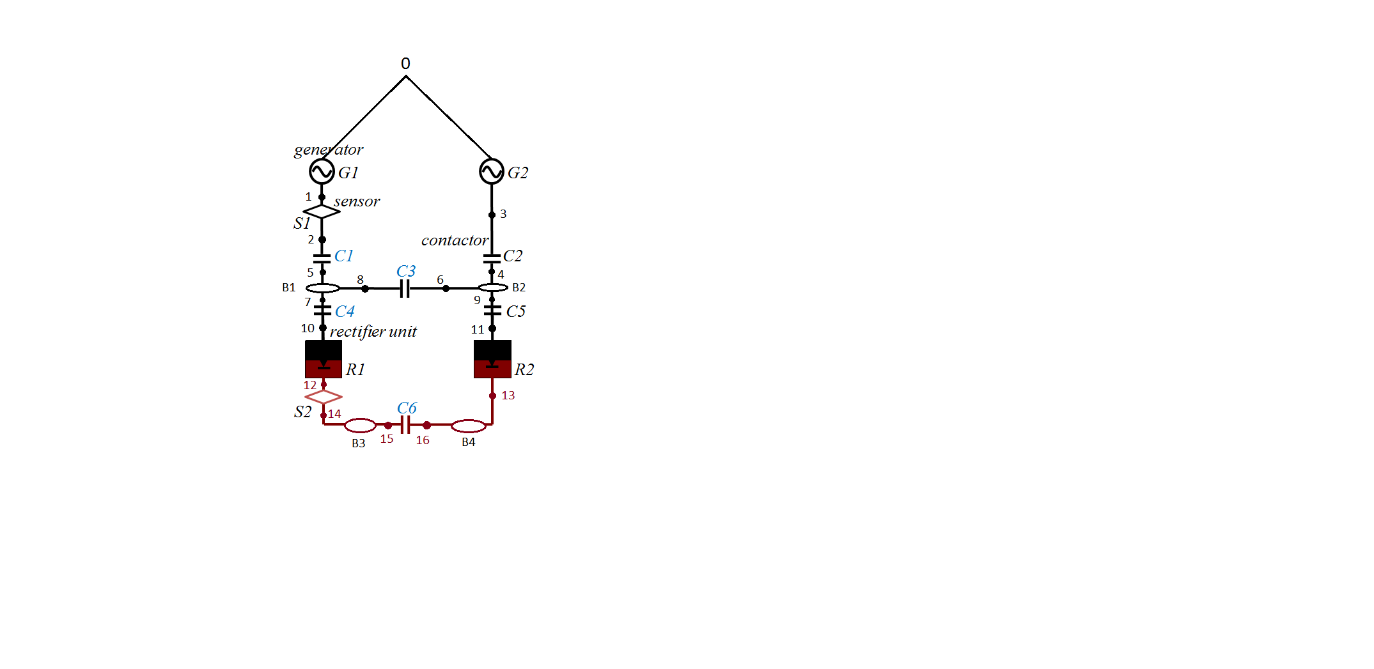

**Sensor 2**

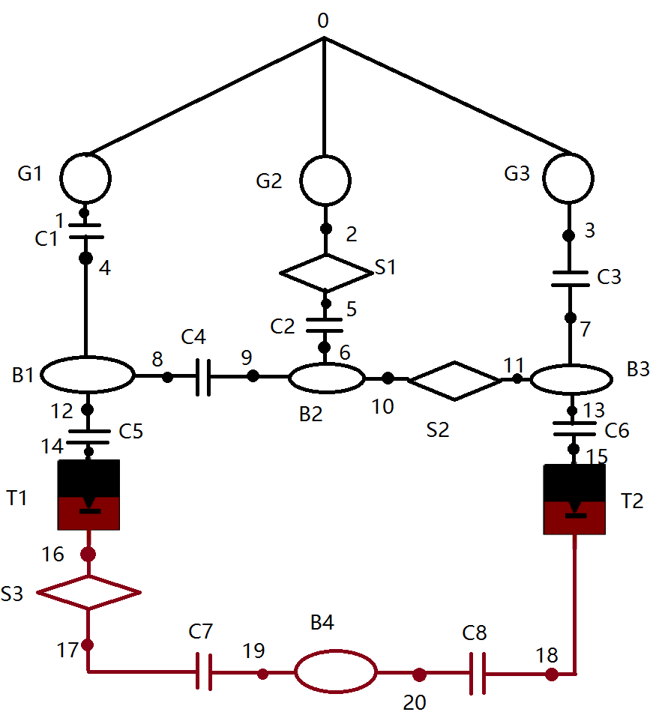

**Sensor 3**

